***ST10444941 – Rendani Nemavhola***

**INSY6112 - Information Systems Test**

**9/25/2025**

**Program: BCA1**

**Group 4**

**Lecturer: Elizabeth**

**Question 1**

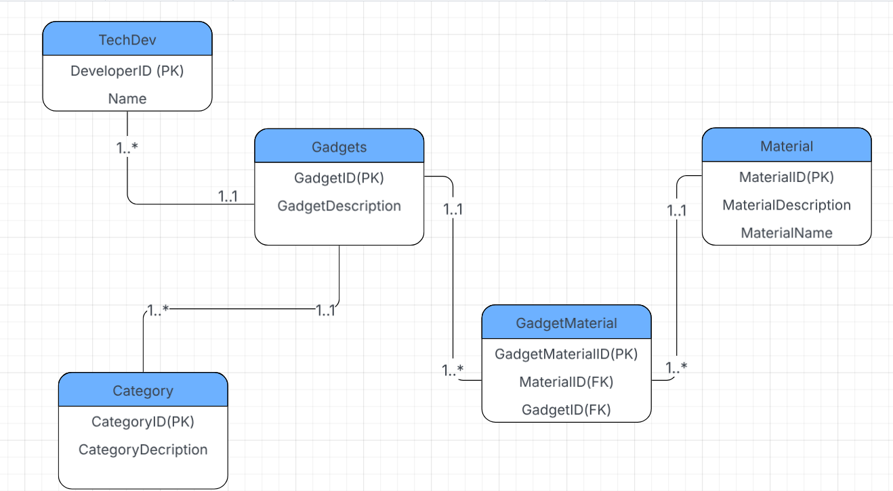

(Lucid.app, 2015)

**Question 2**

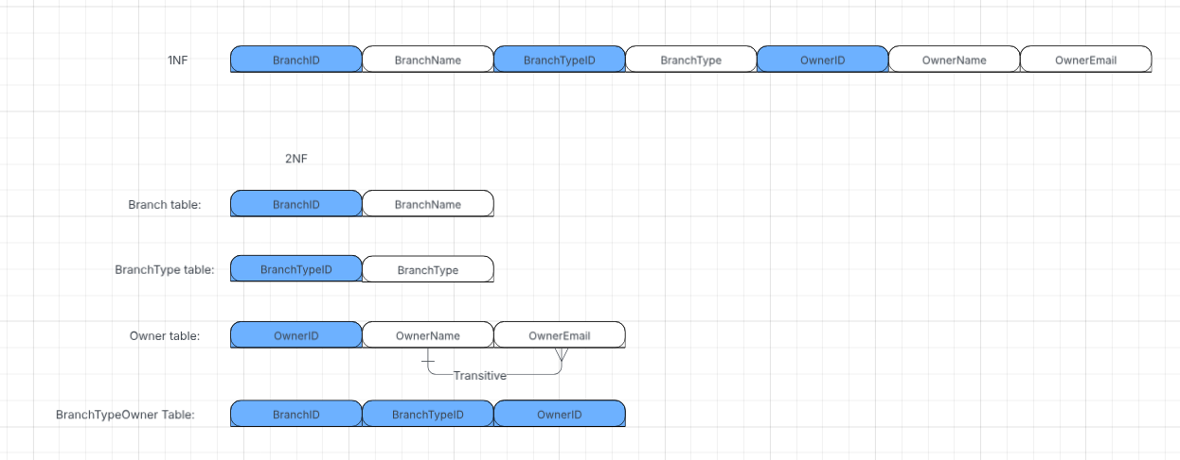

(Lucid.app, 2015)

The steps I took to get this answer was first to find the composite primary keys. Then found and eliminated the partial Dependencies. Then, I went on to creating a dependency Diagram using the information given from the 1NF. For each composite PK, I drew a new table. From then I drew a new Dependency Diagram, that shows the 4 tables with all the dependencies.

**Question 3**

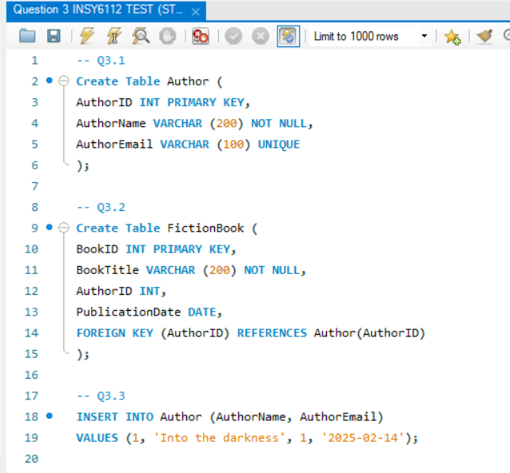

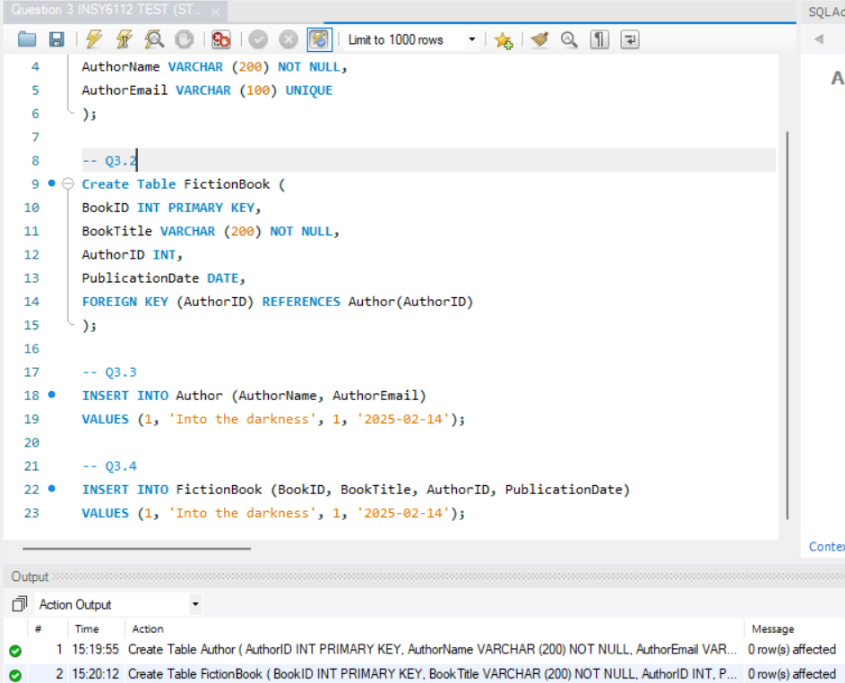

**I have also sent the question 3 folder.**

**Reference:**

Lucid.app. (2015). Lucid visual collaboration suite: Log in. [online] Available at: <https://lucid.app/lucidchart/3ec7d32d-8c7d-477a-b3e3-c62e24ec1f39/edit?beaconFlowId=173BC561E1207F41&invitationId=inv_79f91293-3d3a-479b-95c3-2dbc8cb00247&page=0_0># [Accessed 25 Sep. 2025].